Your Goal As A Printer
- Reproduce jobs as close to the original as possible, and do so in quantities
- Finish jobs so appearance is not marred by “cracking” or splitting of sheet when folded

The Problem
- Faithful reproduction often requires coated papers which reproduce better than uncoated papers.
- Coated papers more prone to cracking
  - Coated layer may split
  - Thicker coating = greater danger
  - Fiber structure may break

Factors Affecting Tendency to Crack
- Paper structure determined during manufacturing
  - treatment of pulp
  - bleaching
  - bond between base and coating
  - length of fibers
  - high fiber content = more stability than low fiber (e.g. recycled, ‘triple coated’)
- Press room
  - printing makes paper less flexible
  - inks & coatings can add to brittleness
- Moisture (tougher problem with digital)
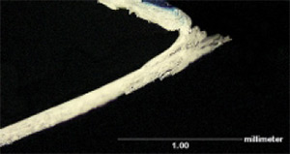
Folded sheet at 25% relative humidity

Folded sheet at 50% relative humidity
images courtesy of Sappi Paper
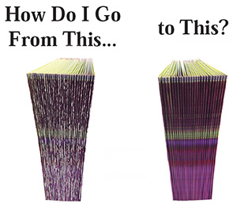
1) Examine 3 factors
(fewer options here with digital jobs)
Test different papers
Test different inks and coatings
Evaluate Moisture
2) Examine creasing (scoring) solutions

Creasing vs. Scoring... Is There a Difference?
Often used interchangeably
Scoring: any means of reducing paper stiffness along a line to aid in folding
Creasing: delamination of sheet by combination of compression and bending around a bead
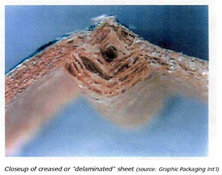

Methods of Creasing
Platen Die Cutter
Uses steel rule pressing sheet into a channel (Technique also used in
modern knife creasing units).
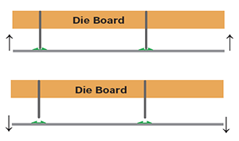
Cylinder or Rotary Die Cutter
Paper passes between cylinders (web) or paper wraps around cylinder (sheetfed)
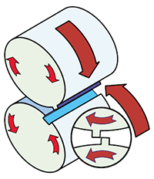
Scoring & Folding Machines using rotary scoring devices


A Comparison for Digital Printers
4 Variables to address for successful creasing
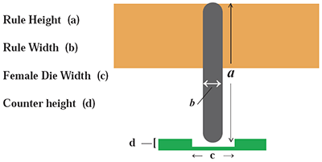
Variables should change with paper weight
Platen (the “gold standard”) & cylinder
Pros
Will successfully crease almost any cover stock
Can modify all 4 variables to suit stock
Cons
Separate, time consuming operation
Requires investment in equipment and labor
Not good for numerous short runs
Die boards need to be made
Lighter stocks (6 pt or less) can be problematic

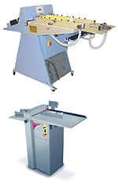
Variations on the Platen
Electronic Knife Creasing Units
Pros
Provides die quality crease
Good for very short runs
No limit to number of creases
Can crease close together
Cons
Slow production speeds
Rule & channel width fixed
( = boxy scores on lighter stocks)
Can’t crease & perf simultaneously
High initial investment
Subject to wear & tear with reciprocating action

Rotary Devices on Folding & Scoring Machines
1) Conventional steel vs. steel methods
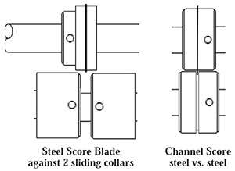
Pros
Channel score works well if stock suited to rule/channel width
Collar style easy to adjust female width
Inexpensive
Cons
Channel score works on limited range of paper, not flexible
(minor changes in paper, moisture, etc = cracking)
Conventional collars rarely work, can’t get compression
Collars difficult to center crease or to fine tune
Easy to damage steel blades or female channel
Tends to “tail off” at end of sheet
Tends to split lead edge
2) Steel vs. Rubber or Polyurethane
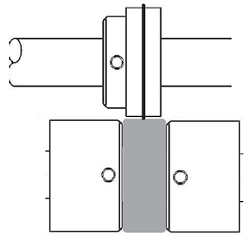
Pros
Better compression improvement over conventional method
Inexpensive
Cons
No female channel
Limited blades available
Limited adjustment
Tends to cut sheet
Tailing off a problem
Ineffective on heavy stocks
3) Rubber male vs. steel female (Tri-Creaser ™)
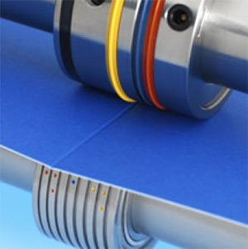
Pros
Equal to Die Crease
Grain Direction Irrelevant
Improved register
High Speed
3 male ribs, 8 female channels covers 90# text thru 16 pt.
Quick changeover
Rubber rib digital friendly
Relatively low investment
Tough to damage
Self-centering female (on most)
Good for short or long runs
Cons
Limited to about 5 devices on folder, 8 on TCM
Replace creasing ribs approx. 500,000 to 1.5 million sheets

The T ri-Creaser...Platen die variables in a rotary format
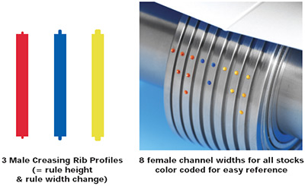

Excerpt from Sappi Paper engineering report
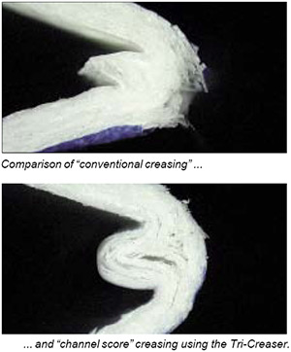
By means of a creasing and folding test we have compared the quality of the creasing devices in respect of coating cracking. With higher basis weights the results of conventional creasing were not satisfactory.
The folding result could be improved by creasing against PU. In this case coating cracking was visible for the high basis weights.
Using the recently developed “channel score“ creasing device we achieved an optimal result in the creasing and folding test, even with high basis weights such as a 350 g/m 2 HannoArt Matt. The quality of this creasing is comparable with that produced in letterpress printing and retrofitting to the folding machine incurs relatively low costs.
For every creasing device it was found that our papers produce a better folding result if the creasing bulge faces inwards. The creasing knife should therefore be applied from the outside towards the inside. Adjusting the knife shaft optimally and applying the minimum pressure to the folded sheet had a positive effect on the result of folding.
For other folding machine manufacturers the descriptions of the folding device differ to some extent from the creasing devices presented in this brochure. Most of the folding machines normally used in the printing industry are either already fitted with creasing devices, or can be retrofitted.
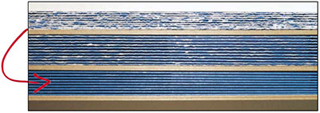
Comparison of conventional creasing, creasing against PU, and channel score creasing (Tri-Creaser) HannoArt Matt 350g/m
Source: Sappi Paper full report at the Idea Exchange www.sappi.com

Common Myths
Myth #1: Always plan a job to fold with the grain
False. Sappi reports that on stocks from about 7-15 pt (170gsm-300gsm) you get better results and a stronger crease when creasing against the grain. The packaging industry has known this for years.
Myth #2: You can’t “crease” in rotary form
False. Whatever the name, a good score/crease means no cracking on the outside + a good bead on the inside. So if the delamination & compression occurs in a rotary form, what difference does it make? It still happens. In rotary, the delamination is incremental. In platen style, the delamination is simultaneous.
Myth #3: If I don’t score on the letterpress, I can’t charge extra.
False...well maybe this is not a myth but a topic for discussion. You invest in tooling to deliver a premium job. Shouldn’t you get a return? Does the customer really care how it’s done?
Myth #4: You can’t use UV coating on a piece that is going to be folded.
False. A good crease will eliminate cracking, even on UV. Admittedly, some coatings are far more brittle than others, and sometimes formulations change for the worse. So test first. Our customers accomplish this every day.

